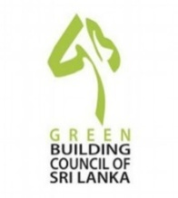
ASSOCIATE PROFESSIONAL TRAINING COURSE 2022

GREEN BUILDING COUNCIL OF SRI LANKA

BOARD OF EDUCATION & TRAINING

August 2018

Registration Form Intake- 39th Batch
Ms/  Mrs./  Dr./Prof. | Name of Participant | Designation | Contact No. | Personal Email Address | Permanent address

Contact Person:
Organization :
Address :
Phone : Fax: -
Email :

How did you get to know about this training program? Please tick the appropriate answer:

From person who has followed the course

From poster
From flyer
From the website other mode: website

Please tick the appropriate mode of payment.
Cheque payment
A Bank Draft/Bank Transfer /Deposit at the Bank
Cash payment at the GBCSL Secretariat

Bank Account details for payment
Account No : 0071545538
Account Name: Green Building Council of Sri Lanka
Bank : Bank of Ceylon
Branch : Torrington Square

Please dispatch the duly filled Registration Form & the payment confirmation document to GBCSL Secretariat;
Post: Chairman, Green Building Council of Sri Lanka, 120/10, “Vidya Mandiraya”, Vidya Mawatha, Colombo 07.
GBCSL Email: srilankagbc@gmail.com Tele: 0762702490

